Jess Hek Django submission – News site
https://github.com/what-the-hek/she-codes-django-news-project-what-the-hek
Contents:
- User not logged in
- Superuser logged in
- User logged in
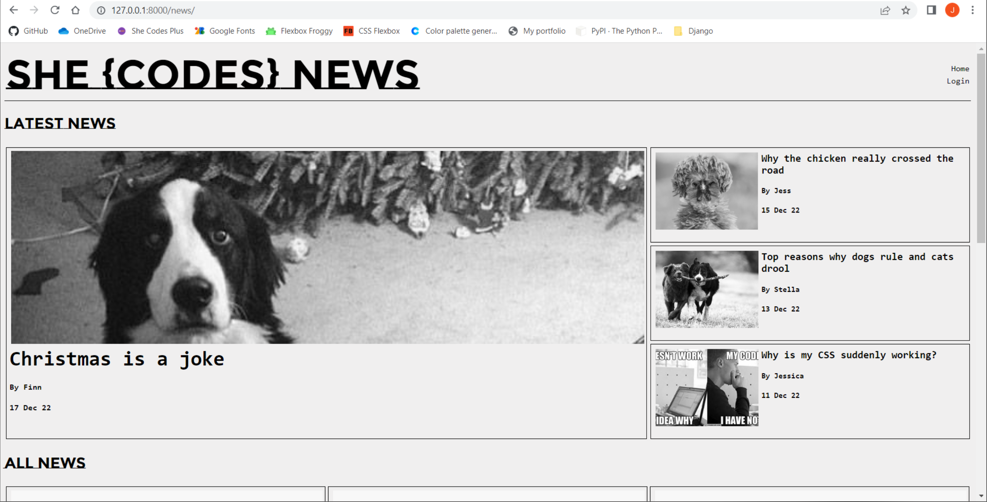

User not logged in
Story view
- Comments are visible but unable to be added
- Link to more stories by author at top

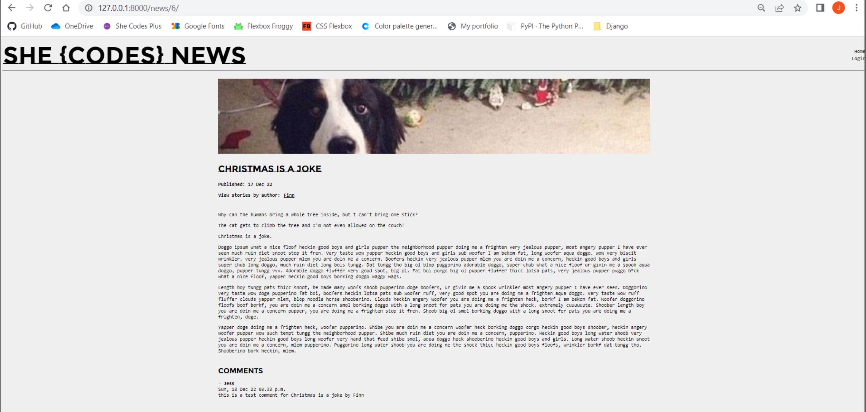

View stories by author
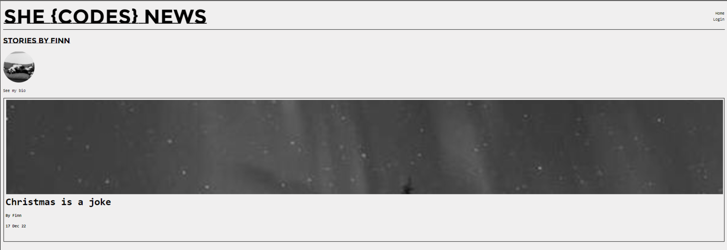
Add story form won’t let you submit while you’re not logged in (if you happen to find the URL)
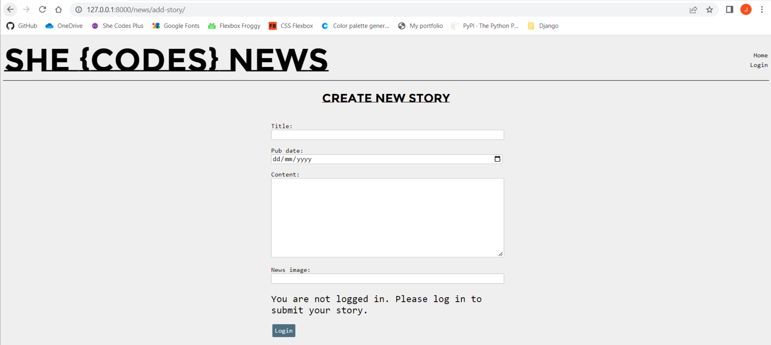

Log in page links to create account
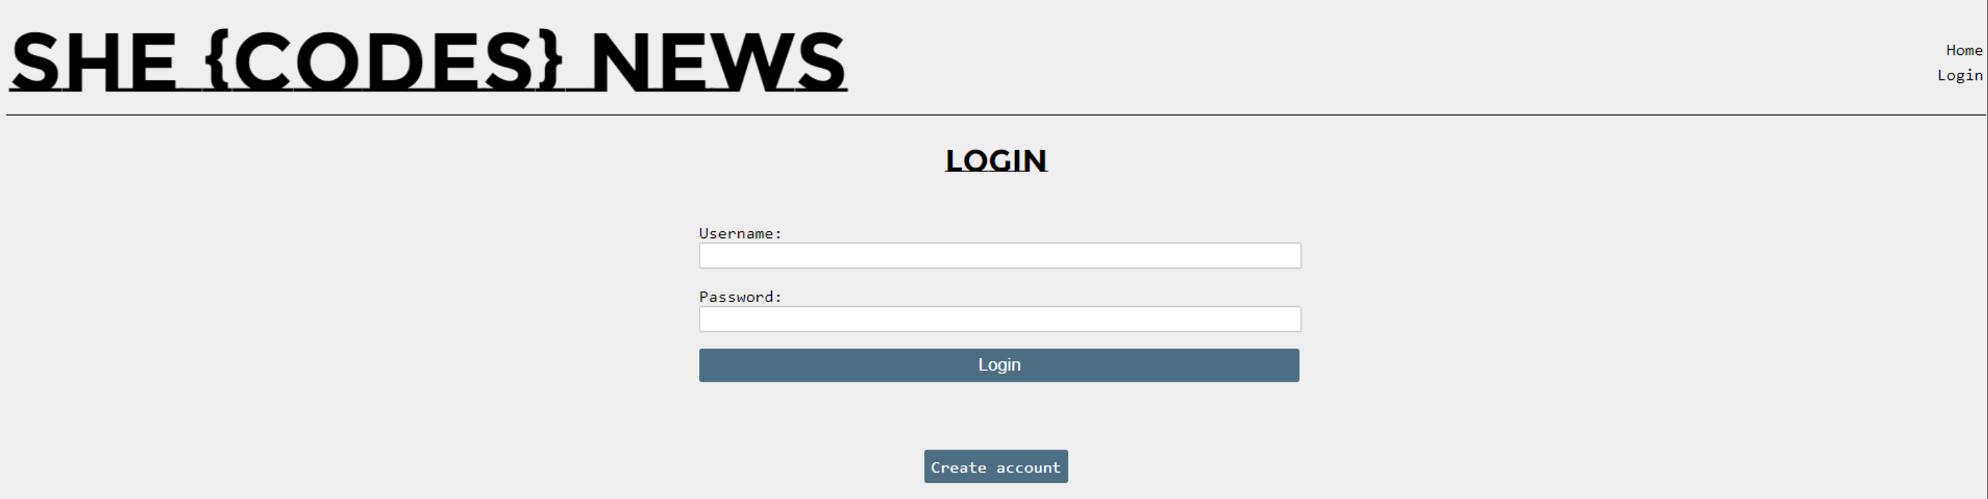

Superuser logged in
- Can see admin link in nav bar, takes you to 127.0.0.1:8000/admin
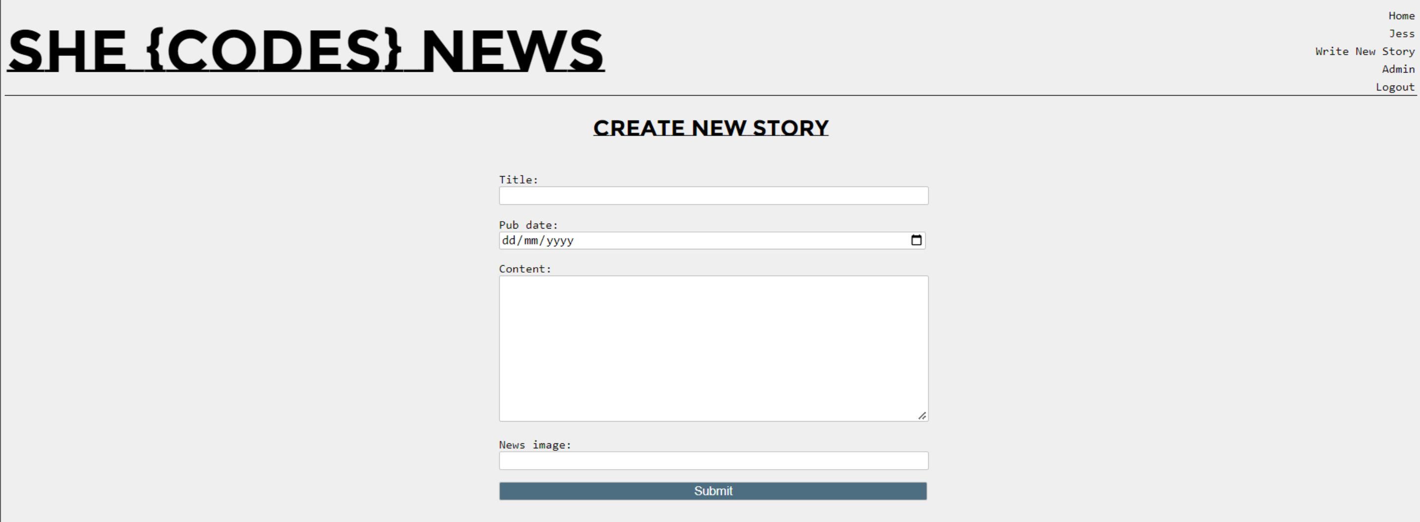

User logged in
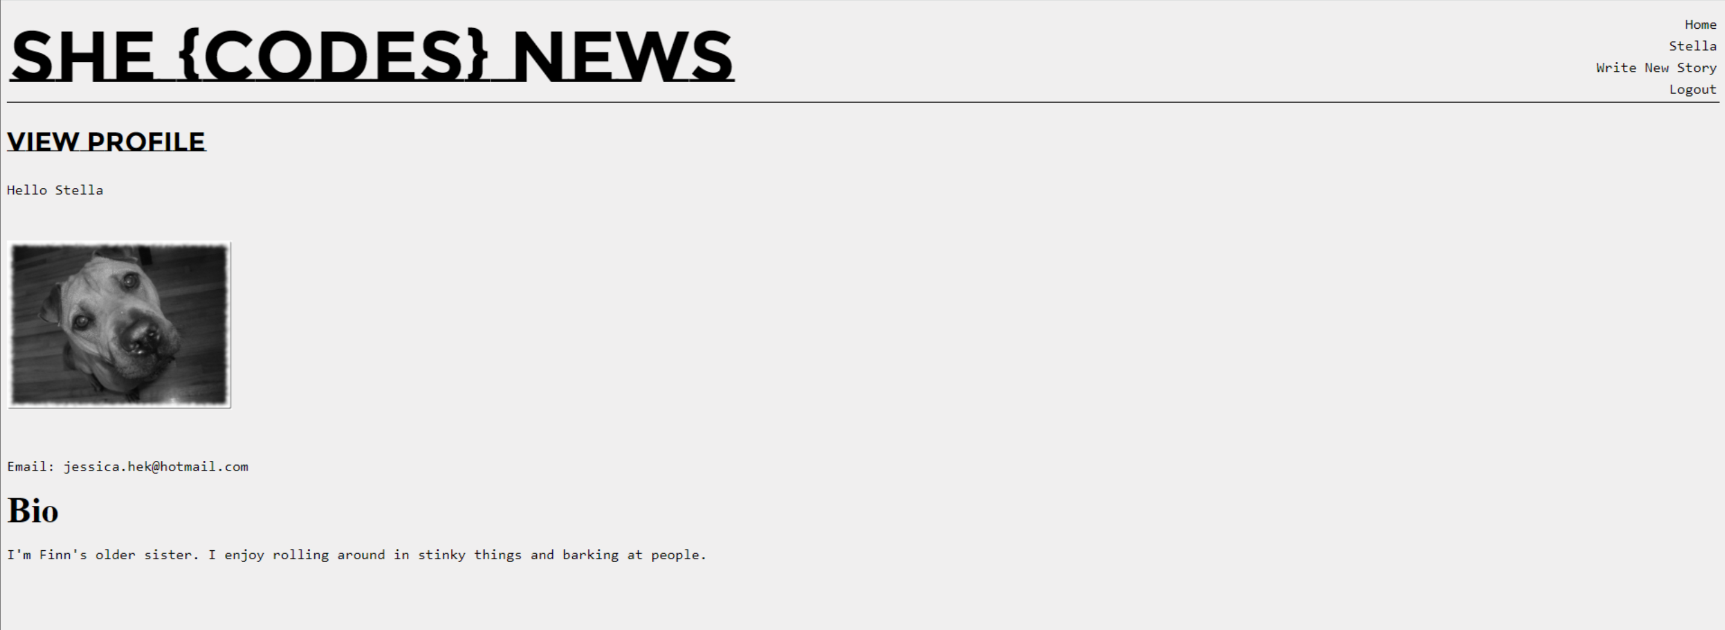

Logged in users can add comments, edit the story or delete a story
When editing, it auto adds a modified date for admin to see, would like to expand on this like a version control of who edited…
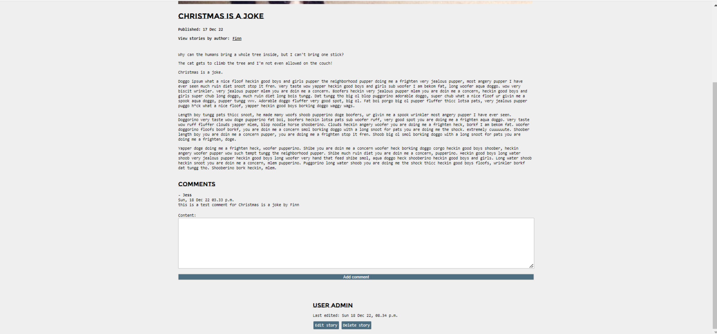

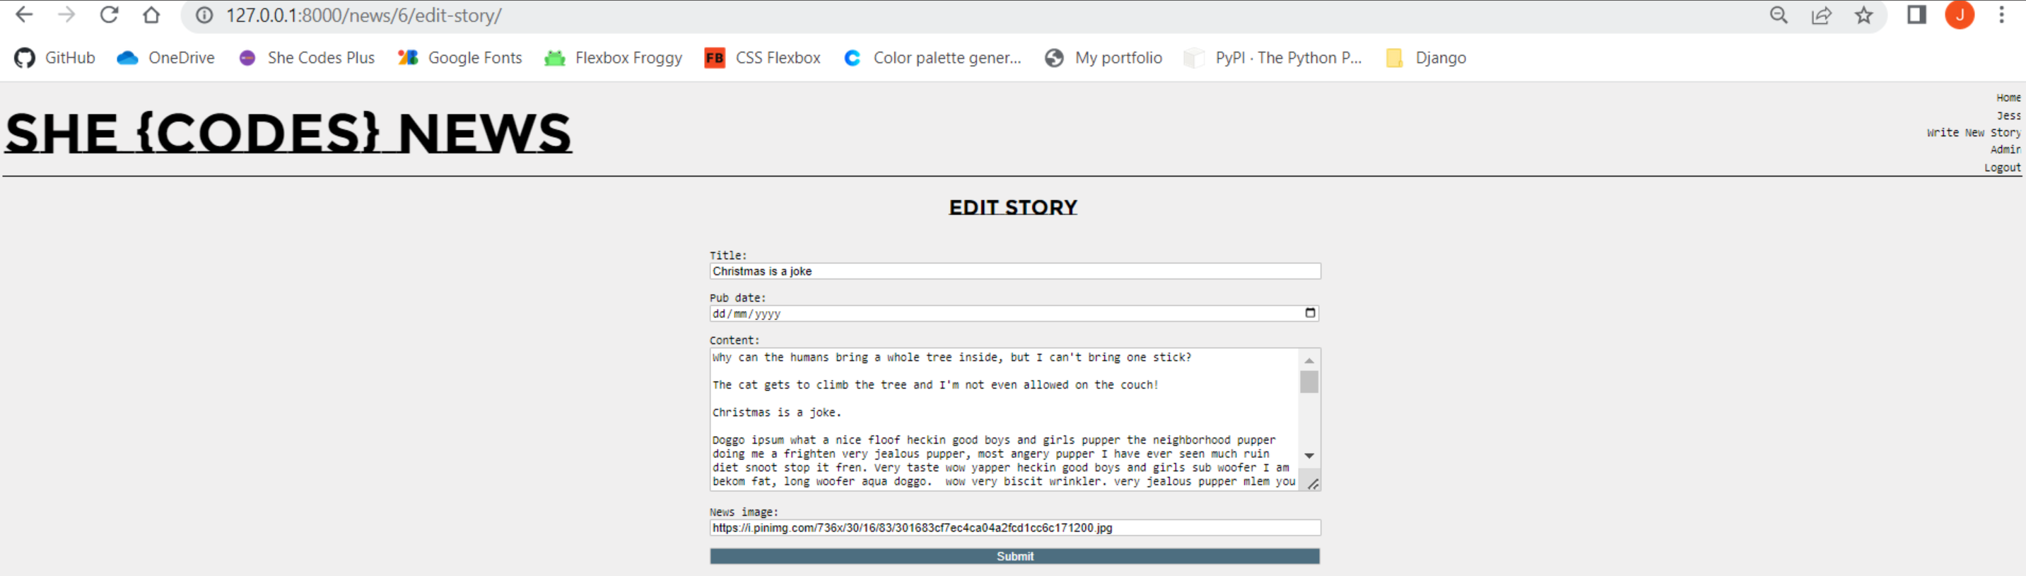
*still working on css
